**Scenario :**

* In The finance manager has an essential role in the company they manage the finance for the company. They have responsibility to manage the finance and other management aspects. The finance manager is ensuring the company finance is utilized properly. finance manager is responsible to maintaining the cost and controlling expenses and provide valuable insight on data regarding financial decision.

**Strategic Goals:**

* Financial resource effectively manage.
* Reduce expense and implement cost control measure.
* Making Strategies to financial decision how to utilize data.

**User Role:**

Finance Manager at Axiom Responsibilities:

* Keeping on track companies financial health.
* Keeping on track and check cost of control is not gone out of budget.
* Making decision based on data insight.
* The authority to execute their cost-saving measures.
* Check and allocated on how much money is allocated and how to spend money.

**Data Prep:**

* In this step we prepare the data preparation and analysis process of combining Oceanic Airline data, Employee flight travel data and US Airport geocoding data.
* Here I mention which step I have taken to import, clean and integrate the data sources.
* What the result and output comes after dataset analysis.

1. Employee flight file:

* I removed the Row Number column.
* I created a clean step of employee flight, grouping all the value of American airline because four different columns and all records are associated with for single airline I group together.
* I did this step because all four airlines listed are the same airline, I want to measure all people who travelled to American airline.

1. Oceanic files:

* I joined Oceanic file with employee flight file, before joining I created a calculated field Airline column in the clean step of oceanic file.
* Now I joined both files Employee flight and Oceanic with the help of UNION.
* In Union1, I created a calculated field Rute1, Route2.
* Rename the Field Route1 to Origin Airport and Route2 to Destination Airport.

1. US Airport:

* In US Airport, I change the role of Airport code to Airport.
* I joined the travel Info data together with US airport data with the help of JOIN, first I joined with Origin Airport code with JOIN1 then I joined with Destination airport code with JOIN3.
* In Union1, I have split the routes into origin airport code and destination airport, so I get longitude or latitude.

1. JOIN1:

* After left Join1, I took a clean step where I renamed fields.
* Airport code to Origin code
* Airport Name to Origin Airport Name
* Latitude to Origin Latitude
* Longitude to Origin Longitude.
* I renamed the field because I what to show the origin word in tableau visualization in dashboard.

1. JOIN3 with Clean6 step:

* After left JOIN3 with US airport origin latitude and longitude with airport code, I took another clean step where did a few needed things like removing column, renaming column and merging field and group values.
* Remove fields: Table Names, Row ID, Passenger ID, Row_ID, File Paths.
* Merge Field: Destination Airport to Airport Code, Ticket Type to Fare Type.
* Group Values: 1st Class to First Class.
* Change Role: Passenger Email to Email.

1. Output file:

* In result, dataset is an integrated file containing Oceanic airline data, travel data and geocoding information for US airport.
* Then final Step, I click on clean6 and create output of flow.

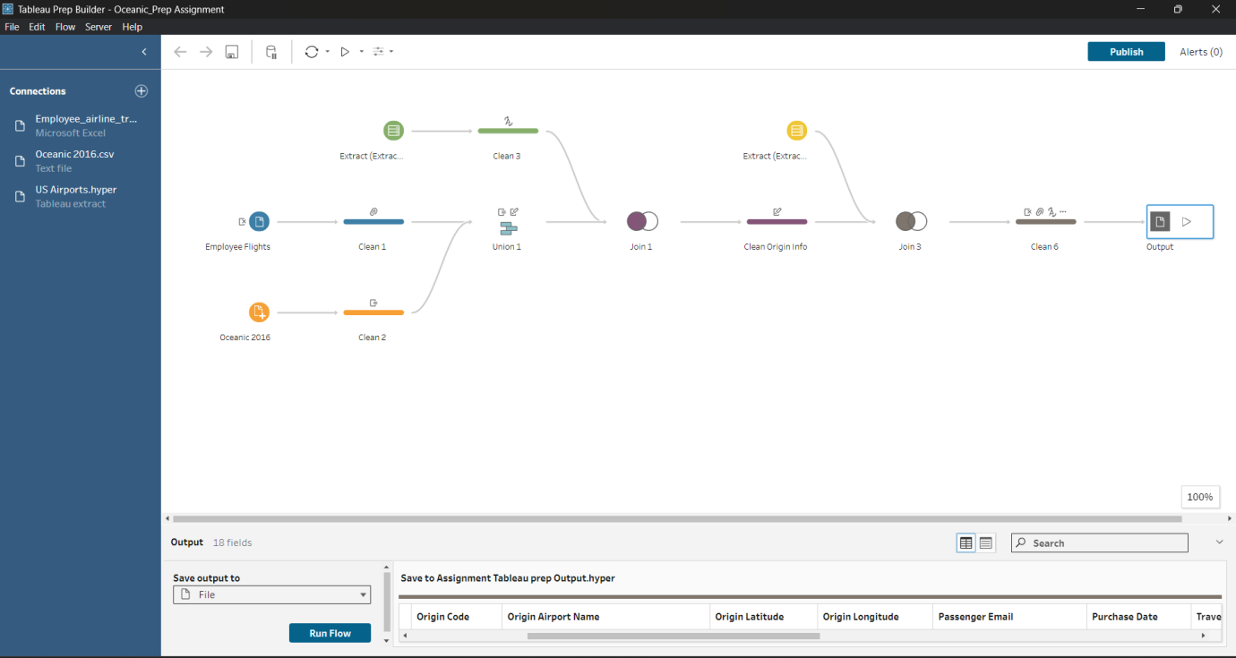

**Visualisation Approach:**

The Visualisation technique we adopt and take hybrid approach that we combine from exploratory and explanatory visualisations. This approach provides a significant initial exploration of the data and patterns (exploratory), as we are also explained the specific KPIs (explanatory)

1. KPI Visualisations:
   1. Most expensive route (Bar chart - Exploratory)

Purpose: Helps user to quickly identify in which state or location have most expensive routes .

Explanation: In bar chart is we check the routes and explore pattern of the chart.

The x- axis Number of Airport mention and Y-axis show prices allowing the finance manager to identify.

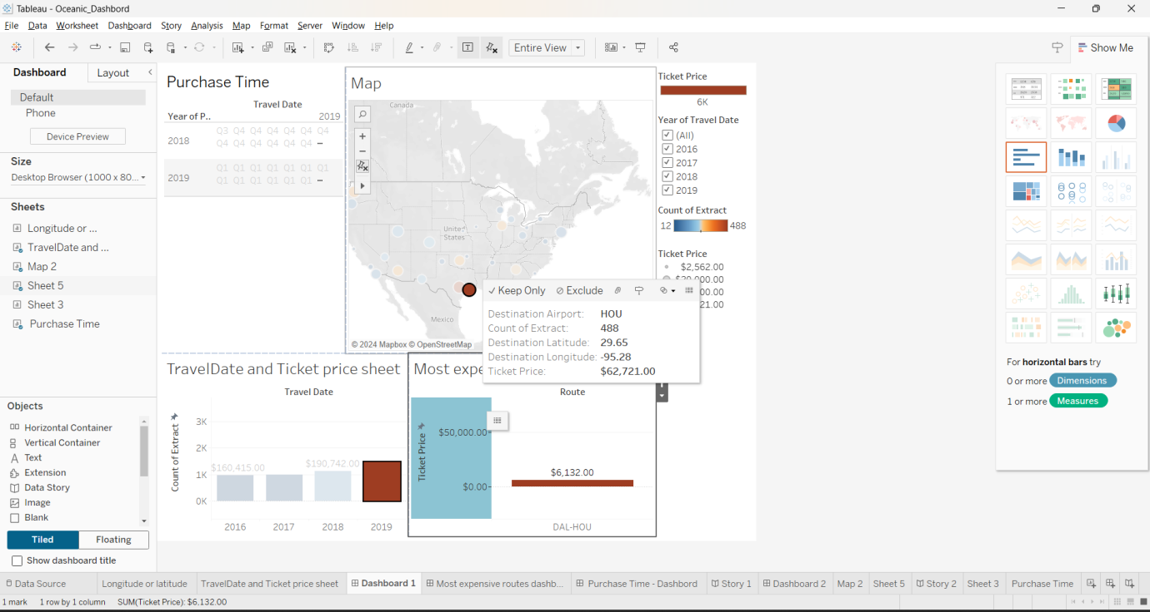Which is the most expensive routes where employee are fly. In my point of view Airport code Houston (DAL-HOU) is most expensive route all the time till 2016 to 2019.

* 1. Purchase Time: (Text Table - Exploratory/Explanatory)

Purpose: Check the purchase time of ticket and actual travel date.

Explanation: In table we can say that purchase of increase in Q1, Q2, people are travel a lot and price is increase in Q3. I just check on Airport code of (DAL-AMA).

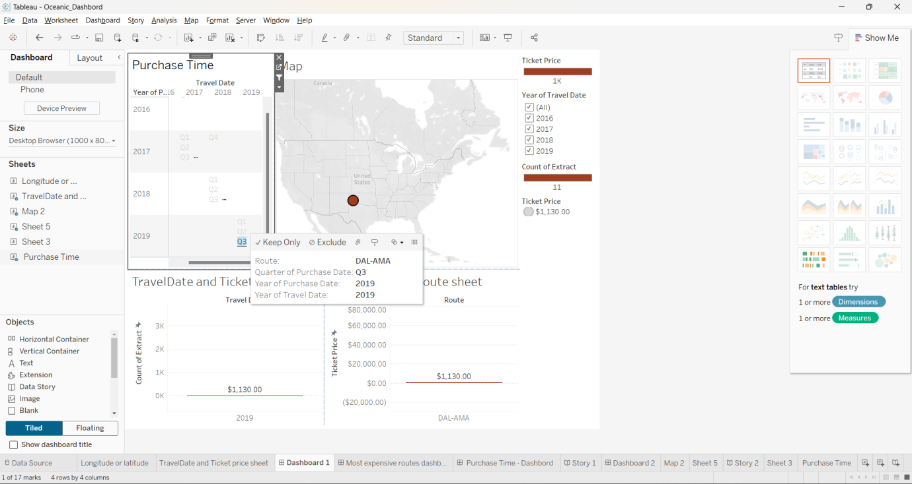

* 1. Geocoding Visualisation (Maps - Explanatory/Exploratory):

Type : GeoSpatial Map

Purpose: Provide geographical context by displaying airport code , destination longitude and destination latitude and ticket price.

Explanation:

Utilizing geocoding data, a map visualisation display what is destination longitude and destination latitude what the total cost of ticket purchased in that year.

Allow the user to identity spatial patterns and potential correlation.

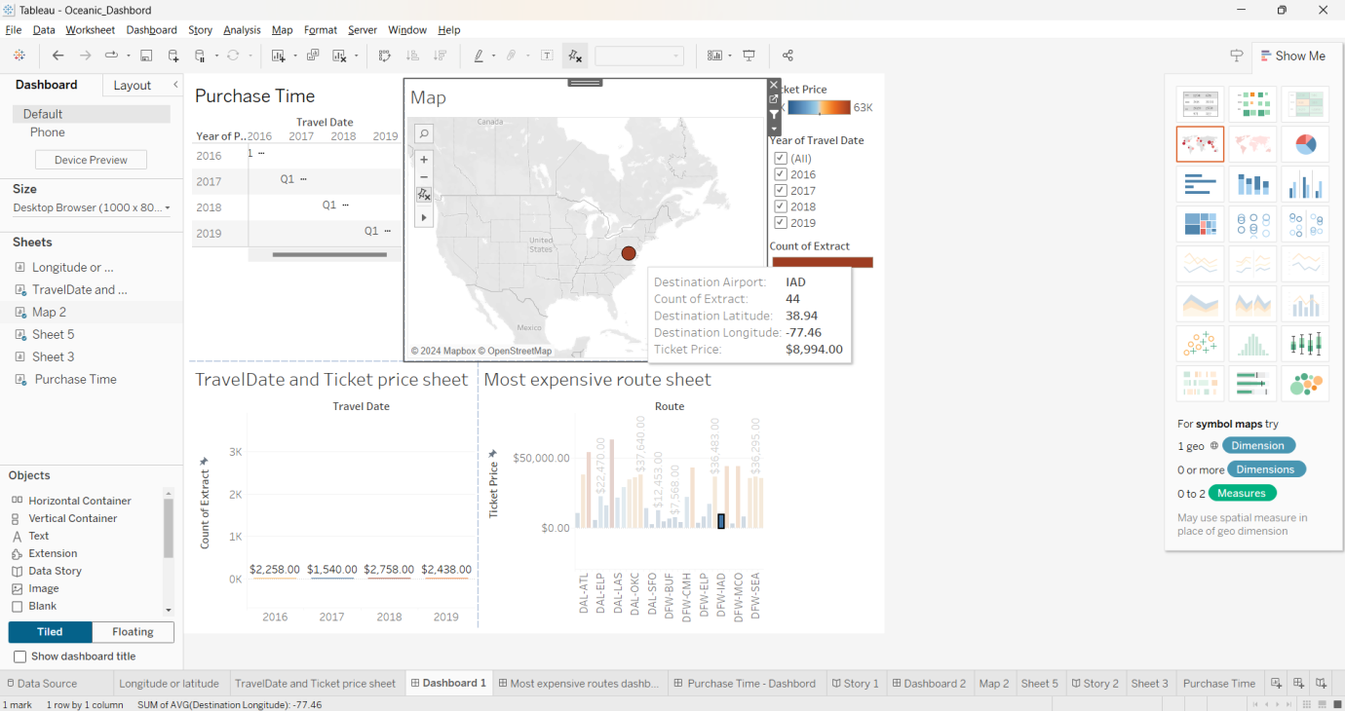

1. Travel Date and ticket price sheet.

Purpose:

Check what the travel date and ticket price how many people are travelling (scatter plot graph)

Explanation :

A scatter graph chart shows that when we're selecting any airport code, it's shown that maximum User are travel in which year of that particular airport code and what the price on particular date. Like in Q3 of 2018 price reached $4593

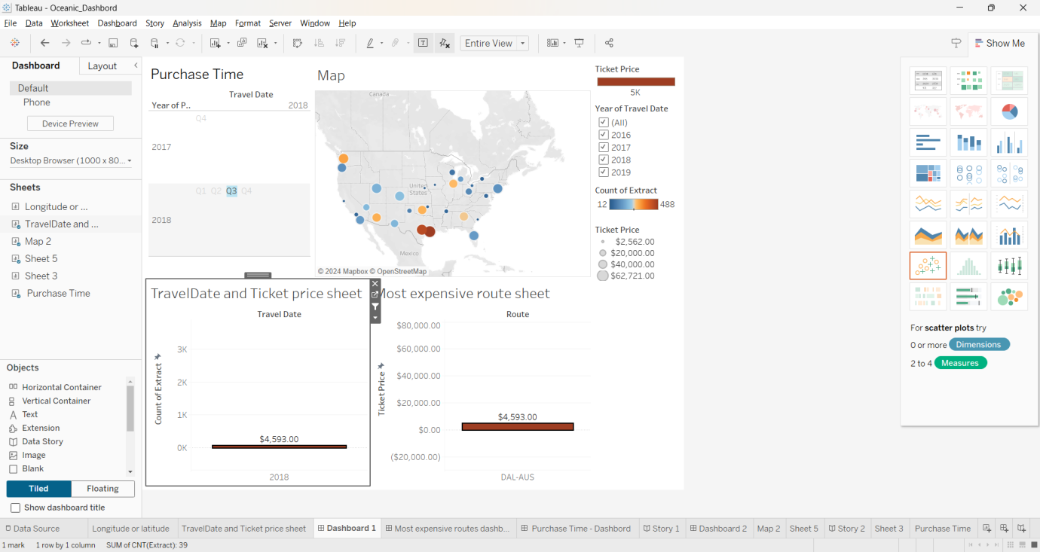

1. Presentation of Data:

In presentation of data is we focused on clarity, meaning full insight of in our work:

Hybrid dashboard

* A unified dashboard integrates the bar graph, line chart, and geospatial map to present a comprehensive view of the key metrics.
* The dashboard provide insight to help the finance manager to understand the data.

Interactive Elements

* Filters are added to enhance the presentation. Filters enable to user to focus on specific things on dimensions.
* These things also make user-friendly presentation.

Consistent Design: Clear title, axis label and other measuring parameters contribute to the overall presentation and aligned with users expectations.

In Summary, data visualisation gives valuable insight to user of raw data.  
The visualisations are designed to empower the finance manager with actionable insight, supporting data-driven decision-making in the context of travel expenses and financial efficiency at Axiom.